Input:

<html>
<head>
<script>
function alertfun()
{
var name= prompt ("This is an alert Box", "Write here");
if (name!= null && name!="")
{
document.write(name);
}
}
</script>

</head>
<body>

<input type ="button" onclick="alertfun()" value="Click Here">
</body>
</html>

Output:
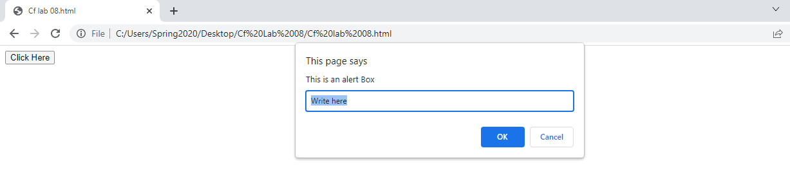

Task No 01: Create a Temperature converter using JavaScript.
Input:
Output:

Task No 02: Create a simple Calculator using Prompt Box. Take two inputs from User and ask the Operation they want to perform.
Input:
<html>
<head>
<script>
const num1 = parseFloat(prompt('Enter First Number = '));
const num2 = parseFloat(prompt('Enter Second Number = '));
var op = prompt('Enter the operator ( +,-,*,/) :');
let result;

if (op=='+')
{
result = num1 + num2;
}
else if (op == '-')
{
result = num1 - num2;
}
else if (op == '*')
{
result = num1 * num2;
}
else if (op == '/')
{
result = num1/num2;
}

document.write("Result of " +num1+ " "+op+ " "+num2+ " = "+result);
</script>
</head>
</html>

Output:
